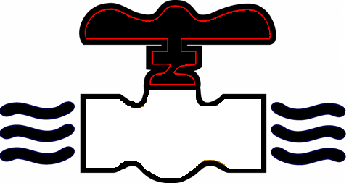
MODERN PLUMBING INDUSTRIES, INC.
255 Old Sanford Oviedo Road ~ Winter Springs, FL 32708
Telephone 407-327-6000 ~ Fax 407-327-2303
www.modernpi.com

PAYROLL DEDUCTION AUTHORIZATION

EMPLOYEE NAME: ________________________________________

Employee Advances (ADV) and Miscellaneous Deductions (MISC) will be deducted by Modern Plumbing Industries (MPI) and repaid with equal weekly installments as agreed to between MPI and me. Any unequal installments will be considered the last payment to satisfy the balance of the obligation.

I hereby allow Modern Plumbing Industries to process payroll deductions for the items indicated below:

AMOUNT: PURPOSE:

1. _______________________ 401K

2. _______________________ ADV - ADVANCE

3. _______________________ CS – CHILD SUPPORT

4. _______________________ DNTL – DENTAL

5. _______________________ HLTH – FAMILY HEALTH INS

6. _______________________ LIFE INS

7. _______________________ MISC – TOOL REPAIR/PURCHASE

8. _______________________ PPL – PREPAID LEGAL

9. _______________________ VISION INS

10. ______________________ _______________________

In the event my employment with Modern Plumbing Industries is terminated for any reason, I authorize the Company to deduct the expense (within Wage and Hour guidelines) from my final wages. I agree to remit payment for any remaining balances not recovered in my final wages.

_______________________________ __________________________
Employee Signature Witness Signature

_____________________________________ _______________________________
Printed Name Printed Name

_____________________________________ _______________________________
Date Date

